Republic of the Philippines

Western Mindanao State University

**College of Computing Studies**

DEPARTMENT OF COMPUTER SCIENCE

Zamboanga City

**Automated Floor Plan Generation and Cost Prediction Using AI-Based Modeling for Residential Construction**

A Thesis Presented to the Faculty of

Department of Computer Science

College of Computing Studies

In Partial Fulfillment of the Requirements for the Degree of

Bachelor of Science in Computer Science

**Arkeo Jewel L. Pausal**

**Zachary Josiah M. Labang**

**Abdel Khaliq B. Abdulla**

**Nur M. Balla**

Researchers

**Salimar B. Tahil**

Adviser

May 2026

Republic of the Philippines

Western Mindanao State University

**College of Computing Studies**

DEPARTMENT OF COMPUTER SCIENCE

Zamboanga City

# Approval Sheet

The Thesis attached hereto, entitled **“Automated Floor Plan Generation and Cost Prediction Using AI-Based Modeling for Residential Construction”**, prepared and submitted by **ARKEO JEWEL L. PAUSAL, ZACHARY JOSIAH M. LABANG, ABDEL KHALIQ B. ABDULLA, NUR M. BALLA**, in partial fulfillment of the requirements for the degree of Bachelor of Science in Computer Science, is hereby **recommended for Oral Examination**.

**SALIMAR B. TAHIL**

Adviser

**APPROVED** by the Oral Examination Committee on May 09, 2025 with a rating of **PASSED**.

**<FIRST_NAME> <MI> <LAST_NAME PANEL 1>**

Chairperson

**<PANEL 2>**

Member

**<PANEL 3>**

Member

**ACCEPTED** in partial fulfillment of the requirements for the degree of **BACHELOR OF SCIENCE IN COMPUTER SCIENCE**

**MR. JAYDEE C. BALLAHO, MIT**

Head, Department of Computer Science

**ENGR. MARK L. FLORES, PhD**

Dean, College of Computing Studies

# Acknowledgment

<This section recognizes the persons and organizations who assisted the researchers in the completion of the thesis. Acknowledgments should be expressed simply and tactfully.>

# Abstract

This research discusses a prototype system that provides floor plans and automatically estimates construction costs using AI and image processing techniques. The system will identify key features from floor plans, identify construction components, and calculate cost estimation models to provide accurate budgeting cost. The research seeks to improve efficiency, and a scalable solution for construction planning. The final output is a model demonstrating the feasibility of AI-driven production of floor plans and cost estimation in real-world house construction planning, potentially setting a new standard for budgeting and project management in the industry.

This research offers a scalable and standardized approach to cost estimation, minimizing financial risks and improving project planning. The findings highlight the potential of AI-driven solutions to enhance budgeting accuracy in construction, setting a foundation for house construction projects..

**Keywords:** Artificial Intelligence, Floor Plan Production, Cost Estimation, Deep Learning, Image Processing

# Table of Contents

Approval Sheet I

Acknowledgment II

Abstract III

Table of Contents IV

List of Figures V

List of Tables V

List of Appendices V

**CHAPTER I**INTRODUCTION 1

Background of the Study 1

Statement of the Problem 4

Objectives 4

Scope and Limitations 5

Significance of the Study 6

Definition of Terms 8

[**CHAPTER II**  
REVIEW OF RELATED LITERATURE 10](#_heading=h.tb0pyrylpyrv)

Related Studies 10

Synthesis 14

Conceptual Framework 16

[**CHAPTER III**  
METHODOLOGY 19](#_heading=h.jijipsbp3z4o)

Research Design 19

Data Source 19

Data Gathering Instrument 20

Data Gathering Technique and Procedures 20

Data Analysis 21

Evaluation 23

Developmental Tools 23

**List of Figures**

Figure 1: Not a Conceptual Framework but a Guide 16

**List of Tables**

T[able 1: Definition of Terms 4](https://docs.google.com/document/d/158xz_HASCHZGKAhKO4My7QpZftSWZI_H2dx6OIEl_2o/edit#heading=h.ml7qtsbw16e1)

[Table 2: Synthesis 7](https://docs.google.com/document/d/158xz_HASCHZGKAhKO4My7QpZftSWZI_H2dx6OIEl_2o/edit#heading=h.7k7l3z5ozlv9)

[Table 3: Developmental Tools and Cost 12](https://docs.google.com/document/d/158xz_HASCHZGKAhKO4My7QpZftSWZI_H2dx6OIEl_2o/edit#heading=h.94osw5h3kt23)

**List of Appendices**

Appendix A: Data Collected 25

Appendix B: System Design 28

Appendix C: Evaluation Tool 29

Appendix D: Relevant Source Code 30

Appendix E: Ethical Clearance 31

Appendix F: Plagiarism Report 32

Appendix G: Research Critique and Editing Certificate 33

Appendix H: Curriculum Vitae 34

# CHAPTER I INTRODUCTION

## Background of the Study

Creating Floor plans are the first and most important step in making a house or any kind of building. People without experience or expertise of architecture and design will have challenges when visualizing their dream home before seeking professional help. One of the importance of construction planning is cost estimation, which ensures that projects stay within budget while maintaining quality ([Blackpole Group, 2024](https://blackpolegroup.com/the-importance-of-accurate-cost-estimation-in-construction/?utm_source=chatgpt.com)). Traditional design tools, such as CAD software or professional floor plan applications, can be difficult for non-experts to use due to technical requirements and specialized terminology.

With the growth of user-friendly applications, industries have shown potential of making automation floor plan softwares to the public. However, Floor plan design often provides use to professionals, prioritizing technical detail over intuitive interaction. Thus, there is a lack of accessible applications that allow non-technical users to create floor plans based purely on their preferences, and needs. Even with digital tools available for designing floor plans, many construction companies still don’t have a reliable way to automatically turn those plans into accurate cost estimates ([Apiko, 2024](https://apiko.com/blog/AI-for-construction-estimating/?utm_source=chatgpt.com)). Some software can help, but it often relies on a lot of manual input or needs heavy customization, which makes it harder to use. Most of these tools also don’t use AI to recognize what's in the floor plans, something that could really boost accuracy ([Cylix Solutions, 2024](https://cylixsolutions.com/case-studies/ai-driven-image-recognition-for-engineering-design-analysis-in-construction?utm_source=chatgpt.com)).

Weber, Mueller, and Reinhart [1] classify automated floor-plan generation (AFG) methods into three types: Top-down, bottom-up, and referential. Top-down starts with overall geometry, then adds details cost-efficient but limits design variety. Bottom-up builds layouts from basic elements flexible but computationally heavy. Referential uses existing plans as templates. These methods highlight each strengths and weaknesses offering to combine them to balance for flexibility and efficiency.

Jain et al. [2] examine generative AI methods for floor plan creation, with Diffusion Models, Vision Transformers, and GANs.They identify key challenges: limited high-quality datasets, difficulty integrating user preferences, and the need for multi-objective optimization to meet functional, aesthetic, and regulatory goals.

Liu et al. [3] review computer-aided layout generation using a cross-disciplinary lens, linking machine learning methods with architectural design. They cover neural network techniques, rule-based algorithms, and evolutionary computation, applied to floor plans, scene layout synthesis, and designs for public/commercial spaces. A key contribution is human-AI collaboration where AI generates the design while preserving creativity.

Li, Benjamin, and Zhang [4] explore using text-to-image models—Stable Diffusion, GANs, and VAEs—to turn hand-drawn sketches or text prompts into usable floor layouts. Their analysis finds diffusion models often yield better spatial coherence, while GANs excel in visual appeal. Challenges include enforcing precise measurements and adhering to architectural standards. They suggest integrating AI outputs with CAD tools to balance generative creativity with technical accuracy.

Meselhy and Almalkawi [5] study AI methods that merge automated floor-plan generation with energy efficiency optimization.These techniques integrate design creation with real-time assessments of ventilation, daylight, and thermal performance, then optimize layouts for sustainability.

This research addresses a prototype system that auto-generates floor plans based on the user’s input and design and estimates the cost of the building.  
An Automated floor plan generator that adapts to its users requirements such as number of rooms, layout style, and space size can empower people to be involved in the design process. This will save time, cost, and enable users to experiment before consulting to professionals.

## 

## Statement of the Problem

When a building project is just getting started, it’s common for everyone involved to have ideas, but not always a clear picture of what’s possible within the budget. While recent AI and automation tools can now generate floorplans in minutes, most of them stop at the visuals. They don’t tell you how much those designs might actually cost to build. This often means architects, engineers, and clients begin discussions without a realistic sense of the financial side, which can lead to costly revisions or even scrapping the idea entirely. What’s missing is a simple, accessible way to explore design ideas while also getting a rough sense of the budget. This study aims to create a proof-of-concept tool that can take a scanned or AI-generated floorplan, measure its spaces and features, and provide a ballpark cost estimate in clear budget tiers (low, middle, high). It’s not meant to replace the detailed work of professionals — instead, it’s here to help spark conversations, guide expectations, and make the earliest stages of design more informed for everyone.

In light of this, the study seeks to answer the following questions:

1. Can the system provide cost estimates from AI-generated floorplans that are reasonably close to manually calculated estimates by professionals?
2. Does showing cost results in budget tiers (low, middle, high) make it easier for users to understand and discuss design feasibility?
3. Will both professionals and non-professionals see the system as a helpful way to explore early design ideas?

From these questions, the research proposes the following hypotheses:

1. H1: The system will produce cost estimates that are within an acceptable margin of error when compared to manual calculations by professionals.
2. H2: Presenting costs in budget tiers will help users grasp the financial picture faster than showing exact figures alone.
3. H3: Users, whether professionals or not, will view the system as a supportive early-planning tool rather than a substitute for professional design and engineering.

By answering these questions, this research hopes to introduce a practical solution for the construction industry—a tool that bridges the gap between design and budgeting, making the process more efficient and less prone to error.

## 

## 

## 

## Objectives

The general objective of this study is to develop an AI-powered system that can create/interpret a floor plan and provide preliminary cost estimates for construction projects.

Specifically, the study will:

* Enable floor plan creation in the system based on user preferences, budget, and structural requirements.
* Generate the perspective view of the house to help users visualize the design.
* Ensure the generated floor plans comply with applicable laws, such as the Philippine Building Code.
* To create a cost estimation algorithm that generates preliminary construction cost ranges based on floor area, and local standard prices of materials.To test and validate the accuracy of the system from computation of cost estimation and input of the user against manually computed benchmarks.

## Scope and Limitations

This study aims to develop a prototype system that provides a rough floor plan design and cost estimate of the construction project in Zamboanga City, Philippines using scanned floor plans as data for training. The system is designed to handle a wide range of building types—from small residential homes to larger-scale developments—by offering budget estimations based on three build categories: low-budget, middle-budget, and high-budget. These estimates consider key structural dimensions and layouts derived from the floor plan, allowing the system to provide flexible, early-stage financial insights. To enhance accuracy, existing AI and machine learning models are integrated into the system, though the research does not involve creating a new AI architecture from scratch.

However, there are several limitations to consider:

Level of Detail - Because the estimates are based solely on provided floor plans area and cost of local prices, they serve as general approximations rather than precise calculations.

Cost Data Reliability - The accuracy of the estimates is dependent on the availability and regular updating of local pricing data, which can fluctuate due to market conditions.

Architectural Complexity - The system may have difficulty interpreting highly detailed or non-standard architectural designs, which could affect estimation consistency.

Professional Oversight - While the system streamlines the estimation process, final budget considerations should still be reviewed by construction professionals to ensure reliability.

Software Integration - At this stage, the prototype operates independently and does not yet integrate with other construction software tools.  
  
Compliance with the National Building Code - The generated plans are not intended for construction, building permit applications, or as substitutes for professional architectural and engineering services. While a few basic spatial considerations from the National Building Code were referenced to keep designs conceptually sound, the tool does not guarantee full compliance with PD 1096. Final validation and refinement of any layout remain the responsibility of licensed practitioners.

## 

## Significance of the Study

Non-technical Users

will benefit from the automated system when choosing and interpreting their design to a professional, reducing misunderstanding and speaking out their ideas.

Construction firms

The study offers a tool that can streamline project planning, optimize resource allocation, and minimize budget overruns.

Engineers and architects

will benefit from an automated system that reduces manual workload and enhances accuracy in financial projections.

Project managers

can make better-informed decisions based on real-time cost estimates, improving overall project management and financial control.

## Definition of Terms

*Note: To add table caption, go to References tab then click ‘Insert Caption’ and then change label to table. Once done go to List of Tables then Update Table.>*

Table 1: Definition of Terms

| **Term** | **Definition** |
| --- | --- |
| 1. GAN | Generative Adversarial Network a machine learning framework, specifically a deep learning model, used for generating new data samples that resemble a given training dataset. |
| 1. VAE | A Variational Autoencoder. VAEs are particularly notable for their ability to generate new, similar data samples that were not present in the original training set. |
| 1. CAD | Computer-Aided Design, is a technology used in engineering to create, modify, analyze, and optimize designs using computer software. |
|  |  |
|  |  |
|  |  |
|  |  |
|  |  |

# CHAPTER II REVIEW OF RELATED LITERATURE

## Related Studies

The process of developing floor plans has changed as a result of the use of Artificial Intelligence (AI) into architectural planning. This has made processes more accommodating to user needs, simpler, and more adaptable. The conceptual foundations and real-world applications of AI in computational floor-plan generation are being studied in a growing volume of research, with a focus on precision, usability, and optimization for particular constraints including sustainability, user needs, and optimal use of space. In the Philippines, the National Building Code (PD 1096) sets the fundamental rules that shape how spaces are designed and constructed. These include minimum room sizes, door widths, and other safety and livability standards. While this study does not aim to create fully code-compliant building plans, some of these baseline requirements were loosely considered in the generation process to ensure that the outputs remain realistic for early conceptualization.

In their thorough study of automated floor-plan generation (AFG) techniques, Weber, Mueller, and Reinhart [1] divide them into three categories: referential, top-down, and bottom-up. Top-down methods start with the general architectural geometry and work their way down to more specific elements, while bottom-up methods start with basic building blocks like walls and rooms and gradually construct layouts. In contrast, referential techniques use pre-existing plans as models or a place to start. While top-down approaches are more economical but may restrict design diversity, bottom-up approaches offer flexibility but can be computationally demanding, the authors stress that each approach has unique benefits and limitations. In order to achieve versatility and computational efficiency, the study proposes alternative methods that integrate these tactics. This paper provides a basis for understanding the range of AI-assisted floor-plan creation techniques that researchers and practitioners can use.

This is expanded upon by Jain et al. [2], who focus on the generative AI methods specifically used in floor-plan creation, such as Diffusion Models, Vision Transformers, and Generative Adversarial Networks (GANs). The lack of large, high-quality datasets, the challenge of implementing user preferences into generated designs, and the requirement for multi-objective optimization to balance effective, aesthetic, and regulatory requirements are the main obstacles to widespread adoption, according to the authors. The study analyses how these methods have evolved between 2020 and 2024, observing notable advancements in spatial logic and image quality. Future directions are also projected, including the creation of more specialized architectural datasets and the incorporation of reinforcement learning for iterative user feedback.

In their review of computer-aided layout generation, Liu et al. [3] embrace a cross-disciplinary approach, relating machine learning approaches with architectural design concepts. They describe essential algorithmic techniques, such as neural network-driven techniques, rule-based algorithms, and evolutionary computation. In addition to home floor plans, their examination includes scene layout synthesis and building design jobs for public and commercial spaces. The review also describes evaluation measures, highlighting the need to assess functional usability, design standard compliance, and geometric accuracy while generating floor plans. This work's aid in human–AI collaboration models, in which the AI produces preliminary designs that architects then revise, maintaining creative control while reaping the benefits of automation, is one of its noteworthy contributions.

The potential of text-to-image generating models for architectural applications is studied by Li, Benjamin, and Zhang [4]. Their research investigates the conversion of hand-drawn designs or text prompts into useable floor layouts using models such as Stable Diffusion, GANs, and Variational Autoencoders (VAEs). According to the study's comparative performance analysis, diffusion models frequently deliver layouts with superior spatial coherence, even if GANs can produce visually striking outputs. The authors do bring forth some disadvantages though, such as how challenging it is to enforce exact measurements and respect to architectural rules. To close the gap between technical accuracy and generative flexibility, they propose combining AI outputs with CAD tools.

Lastly, AI approaches for combining automated floor-plan generation with energy efficiency optimization (AFG-EEO) are examined by Meselhy and Almalkawi [5]. Their analysis includes techniques that combine design creation with real-time performance assessment, evaluating elements like ventilation, daylight access, and thermal performance, and then optimizing layouts for sustainability. The paper emphasizes the significance of computational workflows that concurrently address environmental effect, functional performance, and aesthetic quality. This viewpoint is especially essential when it comes to sustainable building design, as AI has the ability to automate both spatial configuration and adherence to green construction guidelines.

When taken as a whole, these pieces demonstrate how AI-driven floor-plan creation has developed from experimental ideas into a quickly developing field with useful, expandable applications. The body of research continuously suggests a hybrid future in which human-in-the-loop systems, integrated optimization frameworks, and multimodal AI models collaborate to produce ideas that are both fresh and feasible in everyday settings.

## 

## Synthesis

Collectively, the evaluated works show how AI, especially deep learning and GAN-based systems, can be used to automate the creation of floor plans. The majority of the work focuses on increasing spatial arrangement, style adaptability, and design accuracy. While rule-based and hybrid approaches provide greater control at the expense of creativity, GAN-based methods are superior at creating realistic plans but require large amounts of data. Using user input and semantic limitations to improve usability in practical applications is one of the emerging research themes.

Table 2: Synthesis

| **Automated Floorplan Generation in Architectural Design: A Review of Methods and Applications** | **A state-of-art survey on generative AI techniques for floor planning** | **Computer-aided layout generation for building design: A review** | **From text to blueprint: Leveraging text-to-image tools for floor plan creation** | **A review of artificial intelligence methodologies in computational automated generation of high performance floorplans** | **Proposed Study** |
| --- | --- | --- | --- | --- | --- |
| Review of automated floorplan generation in architectural design | Generative AI for floor planning | Computer-aided layout generation | Text-to-blueprint generation | High-performance and sustainable floorplans | Generative Ai for floor planning with cost estimation |
| Algorithmic approaches, rule-based systems, CAD integration | Diffusion models, GANs, reinforcement learning | Optimization, constraint satisfaction, interactive tools | Text-to-image models, prompt engineering | AI-driven energy modeling, generative design |  |
| Comprehensive survey linking automation with traditional workflows | Focus on adaptive, real-time AI design systems for HCI | Emphasizes human–computer collaboration and design flexibility | Bridges natural language and architectural visualization | Integrates energy efficiency and sustainability in AI design |  |
| Highlights evolution from manual drafting to semi/fully automated workflows; identifies integration challenges with current CAD tools | Shows how generative AI can personalize and rapidly produce design variations; predicts future AI-human co-design ecosystems | Demonstrates how constraint-based optimization improves spatial efficiency; stresses designer control over automation | Proves feasibility of creating blueprint-like plans from text prompts; lowers entry barrier for non-experts | Connects generative design with environmental performance metrics; supports green building initiatives |  |
| Strong historical and methodological foundation; provides a broad baseline for understanding automated floorplan systems | Focuses on cutting-edge AI models; forward-looking insights on human–AI interaction for floor planning | Balances automation with human design input; effective handling of spatial constraints | Makes floorplan creation accessible to non-experts; integrates natural language as a design input | Aligns automation with sustainability goals; promotes energy-efficient design generation |  |
| Limited coverage of AI/deep learning methods | Primarily conceptual; lacks large-scale empirical benchmarks | Less focus on AI creativity; more on constraints and optimization | Early-stage; lacks evaluation on architectural accuracy | Niche focus; less coverage of general design adaptability |  |

## Conceptual Framework

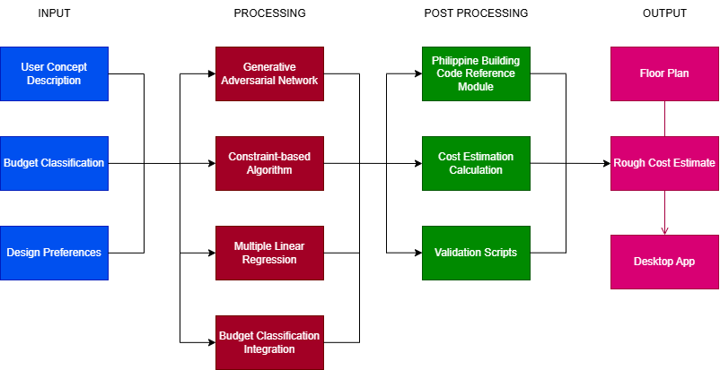Figure 1: Conceptual Framework

The framework outlines a system designed to scan construction floor plans and estimate building costs. The system combines image processing, machine learning models, and data extraction techniques to generate an accurate cost prediction.

1. Input Stage

Import Construction Floor plan: Users specify preferences for desired floor plan. (EX. # of rooms, floors, etc.)

Import Construction Budget Classification: Users are able to select between low-budget, middle-budget, and high-budget

2. Processing Stage  
Budget Classification Integration: Based on selection on the budget type. (low, middle, high)

Constraint-based Algorithms: To ensure layouts meet functional requirements (e.g., room sizes, logical positioning).

Multiple Linear Regression: This model helps predict total costs based on various factors such as total area, rough material quantities, etc.

3. Post-Processing Stage

Cost Calculation: Combines extracted data, material costs, and predictive models to compute the total estimated cost.

Philippine Building Code Reference Module: A programmed set of basic compliance rules for spacing, setbacks, and room proportions for concept validation only.

Validation Scripts: To automatically flag unrealistic layouts before outputting results.

4. Output Stage

Rough Construction Cost Estimate: The system generates a report summarizing the estimated costs.

Floor Plan: The system generates a floor plan with the users preferences and design choices.

The final report is integrated into a user-friendly desktop application for easy access and visualization. The framework illustrates how the system transforms initial user inputs into conceptual floor plans with corresponding cost estimates through an integrated generative design and estimation process. This serves as a proof of concept to aid early-stage planning, offering a visual and financial reference.

# CHAPTER III METHODOLOGY

## Research Design

1. Developmental Research

This study employs a Developmental Research design to create an Automated floor plan generator system to create and visualize the design of a building and construction cost estimation. The design follows a structured process involving system development, testing, and evaluation to ensure accuracy and efficiency. The research aims to deliver a functional, reliable, and scalable AI-powered floor plan generation system for accurate construction cost estimation.

## Data Source

The floor plan samples are collected primarily from public sources from the internet and real construction projects that will be collected from the internet by a third-party known engineer. These floor plans will vary in project size, structural design and complexity for diverse data for model training and testing. Interviews and consultations with engineers, project managers will provide insight into cost estimation and ensuring industrial standards.

## Data Gathering Instrument

Structured interview guides will be used to gather insights from experts such as engineers to understand the standard cost estimation and formulas for refining the model’s accuracy. The cost database will be gathered locally from previous projects with standard cost estimation in the Philippines for references that will be utilized to gather accurate material costs and price data.

## Data Gathering Technique and Procedures

Digital Floor Plans will be collected from architects, Internet, and engineers.

* Gather opinions, references, and feedback from experts
* Typical construction project budgets will be sourced from established databases, industry reports, and official publications.
* A controlled environment will be set up to test the developed model.

1. Step 1 Identify potential data sources, including floor plan repositories, cost databases, and industry contacts.
2. Step 2 Secure permissions from construction firms and experts to access floor plan samples and conduct interviews.
3. Step 3 Develop and refine Python scripts for floor plan feature extraction.
4. Step 4 Train the AI model using the extracted data and collected cost references.
5. Step 5 Conduct expert interviews to validate the model’s accuracy and gather feedback for improvements.
6. Step 6 Test the model with new floor plan samples to assess its performance.
7. Step 7 Compare the model's results with other different models and manual cost estimations to measure efficiency, accuracy, and reliability.

## Data Analysis

The collected data will undergo a structured analysis process to ensure accuracy, reliability, and meaningful insights for the AI-powered floor plan generator system.

1. Data Cleaning and Preprocessing

floor plan features will be standardized by scaling dimensions,

normalizing image resolutions, and converting data into structured

formats for analysis.

2. Feature Extraction and Engineering

Key floor plan components (e.g., walls, windows, doors) will be

identified and extracted using Tesseract OCR and Convolutional

Neural Networks (CNNs) for precise pattern recognition.

3. Model Training and Testing

Machine learning algorithms such as Regression Models,

Convolutional Neural Networks (CNNs) will be applied to predict

construction costs based on floor plan features.

4. Performance Evaluation

Mean Absolute Error (MAE) – to measure average error in cost

prediction. Root Mean Square Error (RMSE) – to evaluate the

model’s ability to handle large cost variances. R-squared (R²) – to

assess the model's predictive accuracy and reliability.

5. Comparative Analysis

The system’s cost predictions will be compared with traditional

manual estimates to evaluate efficiency, accuracy, and time savings.

Statistical tools such as t-tests or ANOVA may be employed to

determine significant differences in performance.

## Software Development

To bring the idea of a floor plan-based construction estimate to fruition, we’ve chosen a combination of machine learning techniques that complement one another across different stages of the process. These include Generative Adversarial Network (GAN) for producing the floor plan layouts, a Constraint-Based Algorithm for alignment with design and user-defined conditions, and a Multiple Linear Regression model to come up with a rough cost estimate. Finally, a budget classification system helps translate that number into a budget tier—low, middle, or high.

1.Generative Adversarial Network (GAN)  
In the context of this study, the Generative Adversarial Network (GAN) serves as the core mechanism for producing conceptual floor plan layouts from minimal user inputs. By learning from a diverse dataset of architectural designs, the GAN can generate realistic and varied layouts that match specified parameters such as building size, number of rooms, and general style.  
2. Constraint-Based Algorithm  
It functions as a rules-driven filter that ensures the generated floor plans align with fundamental building design guidelines and user-defined requirements. Unlike the GAN, which focuses on creativity and variability, the constraint-based system prioritizes logical arrangement, spatial efficiency, and basic compliance with structural and safety considerations, such as minimum room sizes or allowable space allocations.

3. Multiple Linear Regression  
We use a Multiple Linear Regression (MLR) model to predict the approximate construction cost. It’s a simple yet powerful way to calculate a rough estimate based on what’s been recognized in the plan.

4. Budget Classification  
Once we have a cost estimate, it’s helpful to give it more meaning. That’s where our budget classification system comes in. Based on the predicted cost, the system categorizes the project into one of three tiers: low-budget, middle-budget, or high-budget.  
  
Once the machine learning models are trained and tested, the next important step is deployment; turning the models into a functioning, user-friendly application. The goal is to make the system accessible to users.  
  
1. Building the Application Interface

The system will be deployed as a desktop application that allows users to input key building parameters such as total floor area, number of rooms, and general building type. The interface will be designed to be simple and intuitive, guiding users through a minimal number of steps:

* Specify desired building details, such as number and type of rooms (e.g., bedrooms, bathrooms, kitchen, living room), number of floors, total floor area, and intended purpose (residential, commercial, or mixed-use).
* Select their preferred output (e.g., estimate only or include budget classification).
* Click “Generate Concept”, after which the system processes the inputs to produce a tailored conceptual layout and/or cost estimate.

#### 2. Backend Workflow and Model Integration

The backend is where all the machine learning models and supporting logic are integrated into a single pipeline. Here's how it works under the hood:

* Generative Design (GAN)  
  User-provided parameters such as number of rooms, floor count, total floor area, and building type — are fed into a Generative Adversarial Network (GAN). This model generates a conceptual building layout that matches the specified requirements
* Layout Optimization (Constraint-Based Algorithm)  
  The generated layout is then processed by a Constraint-Based Algorithm that ensures room arrangements, dimensions, and structural placements meet logical spatial relationships and basic planning principles. It also aligns the generated design with the chosen budget category, adjusting finishes, space allocations, and features accordingly.
* Cost Estimation (MLR Model)The recognized features (e.g., number of rooms, estimated floor area) are passed into the multiple linear regression model. This model calculates an approximate construction cost based on past training data.
* Budget ClassificationThe estimated cost is categorized into low, middle, or high-budget ranges. These categories are based on thresholds that reflect local construction costs.

#### 3. Output Display

After processing, the application presents the user with:

* A numerical estimate of the construction cost.
* A budget classification (e.g., “This plan falls into the middle-budget range”).
* (Optional) A visual breakdown showing which rooms or areas were detected, and how each contributed to the cost.

This ensures that users not only receive an estimate, but also understand how the result was produced.

## Developmental Tools

Table 1: Developmental Tools and Cost

| **Name** | **Purpose** | **Price** | **Quantity** | **Total** |
| --- | --- | --- | --- | --- |
| **Laptop/Desktop** | **Coding** | **40,000** | **4** | **20,000** |
| **Programming**  **Languages** | **Environment** | **Free** |  | **0** |
|  |  |  |  |  |
| **Server** | **Manage Data and Security** | **45,000** | **1** | **2500** |
| **Grand Total** | | | | **82,500** |

## Evaluation

# The developed AI-powered floor plan scanning system will be evaluated using a combination of performance metrics, comparative analysis, and expert validation to ensure its accuracy, efficiency, and reliability.

# The system's performance will be compared to traditional manual cost estimation methods and different models.

# Industry professionals, such as architects and engineers, will review the system’s output to ensure its estimates align with real-world construction costs. Expert feedback will also help identify areas for improvement.

# Appendix A: Data Collected

Data sources:

<https://www.kaggle.com/datasets/adilmohammed/floor-plan-images-and-their-details>

<https://www.kaggle.com/datasets/asutoshprad/floor-plan-dataset>

Floor Plan Formulas:

Basic Area Calculation

Formula:

Area=Length × Width

Description: For rectangular or square floor plans, the area is calculated by multiplying the length by the width. This simple formula is used for basic geometric layouts.

Irregular Floor Plans

Formula:

Area=∑(Area of individual segments)

Description: For complex or irregular floor plans, the area is calculated by dividing the plan into smaller, regular shapes (e.g., rectangles, triangles, circles) and calculating the area of each segment. The total area is then the sum of the areas of all these segments.

# Appendix B: System Design

**UI Prototype**

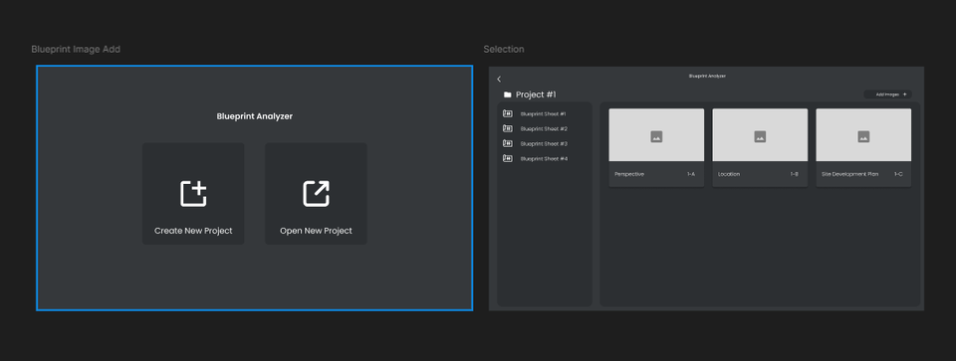

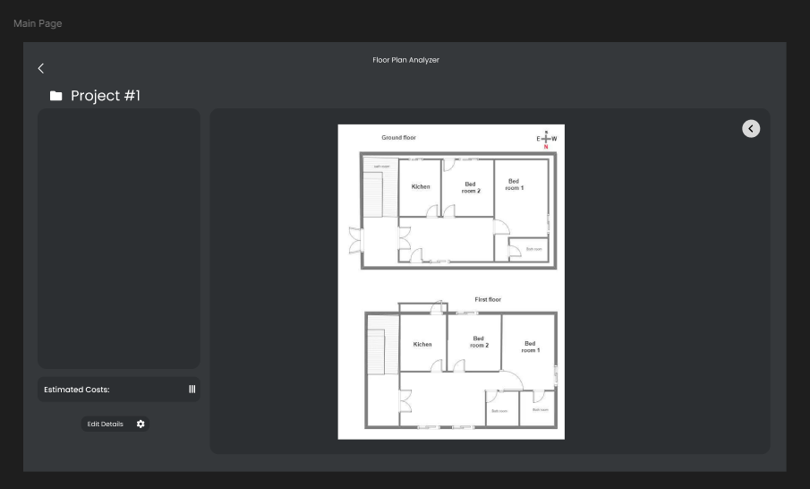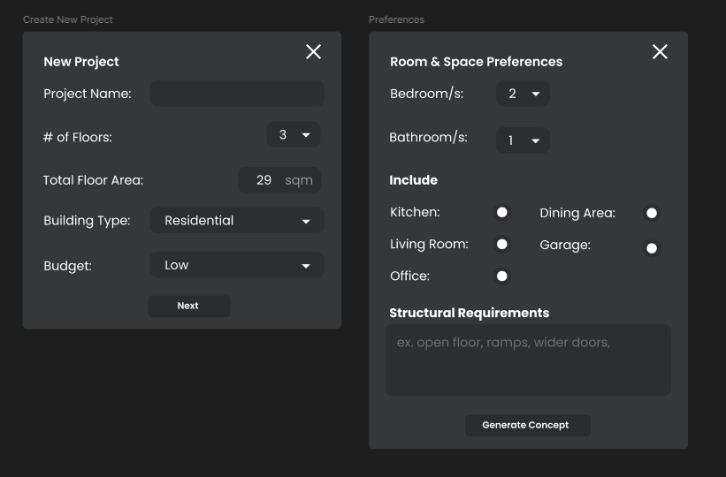

**System Architecture**

System Architecture Flow:

[Enter User Preferences] → [Image Preprocessing] → [Floor Plan Output] → [Cost Estimation Process] → [Output: Projected Rough Estimate Cost]

# Appendix C: Evaluation Tool

Expert Evaluation Rubric for Prototype Accuracy

| Criteria | Score (1-5) | Remarks |
| --- | --- | --- |
| Accuracy of Cost Estimation |  |  |
| Responsiveness to Floor Plan Input |  |  |
| User Interface Clarity |  |  |
| Usefulness to Real-World Projects |  |  |
| Overall System Reliability |  |  |

# Appendix D: Relevant Source Code

# Appendix E: Ethical Clearance

# Appendix F: Plagiarism Report

# Appendix G: Research Critique and Editing Certificate

# Appendix H: Curriculum Vitae